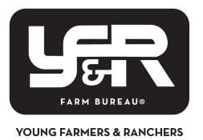

SOUTH DAKOTA FARM BUREAU FEDERATION

2024 DISCUSSION MEET

APPLICATION AND INFORMATION SHEET

Competitor’s Name: _____________________________________________________________________________

Phonetic Pronunciation: _________________________________________________________________________

Address: ______________________________________________________________________________________

City: ________________________________________ State: ___________ Zip: ___________

Phone Number: _____________________________

Email: ________________________________________________________________________________________

Gender: ___________ Age: __________ Date of Birth: ________________________

We certify that the above-named applicant has met all the competitor requirements as set out in this year’s AFBF YF&R Discussion Meet Manual.

Signed:

County/Collegiate President: ______________________________________________________________________

Or:

District YF&R Committee Member: _________________________________________________________________

By participating in the event, the undersigned contestant warrants that he/she fully and unconditionally agrees to and accepts the YF&R Official Contest Rules and the decisions of the YF&R Committee, which are final and binding.

Competitor Signature: __________________________________________________________________________

**Discussion Meet Application form must be mailed on or before**

**November 1, 2024**

Mail to:

South Dakota Farm Bureau Federation

Attention: YF&R

714 N Poplar Ave

Pierre, SD 57501

Or email:

lowell@sdfbf.org